**ARTYFY**

**Project Team - 5**

**COMP8117 Fall 2021**

**Sprint - 2 Report**

# **Objectives of the sprint**

The objective of the sprint is to implement admin persona of the system. We are introducing museum specific registration for the art owner which gives the ability to add and edit their art in the system. This sprint also include these functionalities of adding and editing the art. By the end of this sprint user can also be able to see the list of arts museums available for them. This sprint includes below tasks related to above features

1. Add Art
2. Delete Art
3. Edit Art
4. User Registration – Adding details about Art Owner
5. View List of Art Galleries and Museums
6. Algorithm design for Art Finder

# **Tasks**

* **Scrum meetings**

Conducted the scrum meetings in the team to gather the requirements which are provided by the customer and discussed the progress and implementation throughout the sprint.

* **Meeting with customer**

Customer gave related inputs and validation is done for every screen present and for milestone meeting, required presentations & feedback is taken at end of sprint.

* **Specifications**

Specify the registration of museum for Art Owner.

**Introduction:**

When ever, a user choose to be an art owner, they need to feed their museum details to the system in order to present their arts through the application.

**Inputs**

Owner need to choose a picture and should provide details like name, description and location(residing city and coordinates).

**Processing**

Basing on inputs details which was given by art gallery owner or museum owner, the details are automatically saved into museums list.

**Output**

Owner can now be able to add art and those will be visible to end users

* **Specify Add, Edit and Delete art by art owner**

**Introduction:**

We would like to implement all the mentioned transactions related to Artwork such that user can easily get UI to perform such operations. All the information related to artwork is fetched from the database through specific interfaces assigned for the tasks only, this helps user to find, store, remove and edit information about any new artwork or existing ones.

**Inputs:**

Users add required information to add, delete, update and fetch information from database. For adding information related to art, user needs to add basic details such as name, phone number, email, etc. For fetching details, user adds artid and the application will fetch information further from database. For deleting details about art, user adds artid to delete the record from database. For update any detail, user adds information in form, and it gets updated in database.

**Processing**:

After receiving information from user, the application start processing the contents. For add operation, application receive details and transfers it into relevant interface to save it further to database after applying appropriate logic. For update, delete and fetch operations, similarly application receives information and apply relevant logic to make the data sufficient to be saved in the database, which can be used in future.

**Output:**

After adding data for add operation in form, user gets a unique artid which will be used for future reference. For other transactions, user will be notified for the successful or unsuccessful operations performed.

* **Define the algorithm for the Art finder feature**

The practice of identifying and labeling groupings of pixels or vectors inside an image based on specified criteria is known as image classification. One or more spectral or textural features can be used to develop the classification rules. There are two types of categorization method which are supervised and unsupervised. The image recognition is the capacity of software to recognize objects, places, people, writing, and activities in pictures.

**Design** -

We are using location of the user to facilitate near by museums feature. So user must accept location access and one more design constraint is owner must be at museum when they needs to register the museum. Picture quality art is dependent on the hardware specification of device of art owner. Authenticity of details must be validated if the scope of project is extended, current scope is restricted to authenticity of owner.

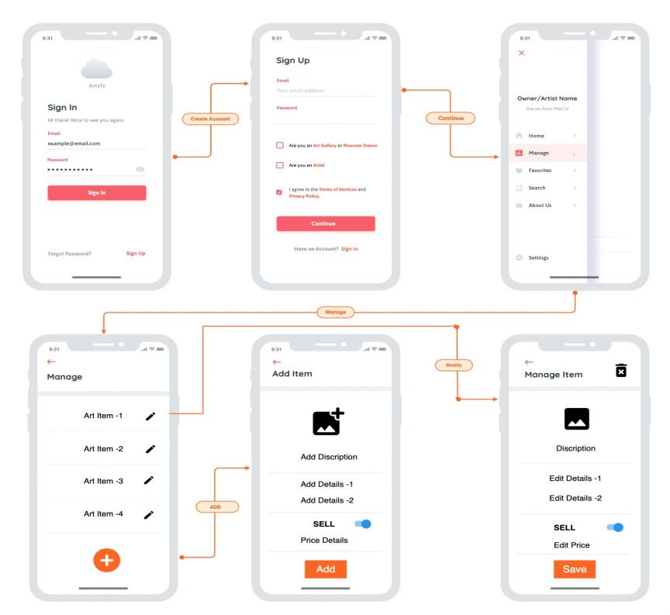

Figure : Mock UP for edit art

**Implementation -**

The art gallery owners are able to register their art galleries after their login into their application as gallery owners. In the art gallery registration, the owner submit the gallery image, gallery name, gallery description and the latitude & longitude details of the registered gallery was provided by the application based on the current location when the owner is performing registration.

The art gallery owner can perform the activities like addition of new arts, modification of existing art details, delete the arts in their registered art galleries. The users will able to view the art galleries which was registered by art gallery owners and their details based on the near by location.

**Test**

Testing should be done on validation of accessing location, addition of museum details in database, visibility of museum to end user, operations on art items, synchronizing of changes done and view of art by owner & user respectively and finally their updation in database.

1. **Provisional Planning of the Sprint**

|  |  |  |  |  |  |  |
| --- | --- | --- | --- | --- | --- | --- |
| **Task** | **PSD** | **PED** | **Expected Duration** | **Expected Assignee** | **Dependent Tasks** | **Expected artifacts** |
| Meeting with customer | Oct 6 | Oct 6 | 1h | Hardik |  | Meeting report |
| Add art by Art Owner | Oct 18 | Oct 25 | 1w | Yuva  Varun | 75 |  |
| Edit Art by Art owner | Oct 18 | Oct 26 | 1w 1d 2h | Bhargav  Deepak | 76 |  |
| Delete Art | Oct 25 | Oct 27 | 2d 4h | Deepak  Yuva | 77 |  |
| View the List of Museums/ Art Galleries | Oct 18 | Oct 26 | 1w 1d | Naryana  Shruthi  Nupur | 78 |  |
| System Testing for Sprint-2 | Oct 27 | Oct 28 | 5h | Yuva | 79 |  |
| Project Management : Sprint - 2 | Oct 18 | Oct 30 | 3w | Yuva | 80 |  |
| User Registration - Adding details of Art Owner  Art Finder: Algorothm Design | Oct 18 | Oct 22 | 3d 6h | Pravallika | 85 |  |
| Art Finder: Algorothm Design | Oct 28 | Oct 29 | 1d 4h | Narayana  Yuva | 86 |  |

1. **Effective Planning**

|  |  |  |  |  |  |  |  |
| --- | --- | --- | --- | --- | --- | --- | --- |
| **Task** | **Related Tasks** | **PSD** | **PED** | **Expected Duration** | **Expected Assignee** | **Dependent Tasks** | **Expected artifacts** |
| Meeting with customer |  | Oct 6 | Oct 6 | 1h | Hardik |  | Meeting report |
| Add art by Art Owner | 1)Add art : UI design  2)Add art : Backend  3)Functional Testing : Add art | Oct 18 | Oct 25 | 1w | Yuva  Varun | 75 |  |
| Edit Art by Art owner | 1)Edit by Art Owner – User Interface  2)Edit by Art Owner- Backend  3)Functional Testing- Edit by Art Owner | Oct 18 | Oct 26 | 1w 1d 2h | Bhargav  Deepak | 76 |  |
| Delete Art | 1) Delete Art  – User Interface  2) Delete Art  - Backend  3)Functional Testing- Delete Art | Oct 25 | Oct 27 | 2d 4h | Deepak  Yuva | 77 |  |
| View the List of Museums/ Art Galleries | 1)View the List of Museums/ Art Galleries- Design of List View  2) View the List of Museums/ Art Galleries- User Interface  3) View the List of Museums/ Art Galleries- Defigning schema in Database  4) View the List of Museums/ Art Galleries-Backend  5)Functional Testing- View the List of Museums/ Art Galleries  6)Functional Testing-Loading the list Art Galleries | Oct 18 | Oct 26 | 1w 1d | Naryana  Shruthi  Nupur | 78 |  |
| System Testing for Sprint-2 |  | Oct 27 | Oct 28 | 5h | Yuva | 79 |  |
| Project Management : Sprint - 2 | 1)Daily Scrum  2) Sprint Planning  3) Sprint End : Retrospective | Oct 18 | Oct 30 | 3w | Yuva | 80 |  |
| User Registration - Adding details of Art Owner | 1) User Registration - Adding details of Art Owner  – User Interface  2) User Registration - Adding details of Art Owner  - Backend  3)Functional Testing- User Registration - Adding details of Art Owner | Oct 18 | Oct 22 | 3d 6h | Pravallika | 85 |  |
| Art Finder: Algorothm Design |  | Oct 28 | Oct 29 | 1d 4h | Narayana  Yuva | 86 |  |

**w : week

d : day

h : hours

1. **Review**

* The museum registration for owner persona is working as expected.
* We have decided to change location of museum registration as it seems more meaning full in manage section as we are improvising edit of museum details which will be done in spint-3.
* Add, delete and edit of art is working as expected and synchronizing changes between owner and user is sometimes failing which will be resolved in sprint-3
* OTP dependency will be updated in sprint-3 for increasing the speed.
* Developing the algorithm in python as we found it java is more complex after the analysis from sprint-1

1. **Retrospective**

* We organized scrum meetings with all the team members based on their availability and communicated regarding our individual contribution and their respective tasks.
* Based on the customer inputs and suggestions we implemented the features and their functionalities accordingly.
* Tasks allocation and time logging was done in Jira.
* As we focused more on the implementation in this sprint, we will also give more preferences towards the documentation such as sprint report, presentation to the customer and other required documents along with the implementation.